Sitecore Content Usage Tools

User Manual

Contents

Introduction 2

References 2

Installation 2

Finding unused content in the content tree 4

See what pages use a particular piece of content from the content editor 5

See what other pages content is being used on from the page editor 6

Using reports to get an overview of where content is being used or obsolete 8

# Introduction

This document describes how you can use the Sitecore Content Usage Tools module. It describes in detail what steps to follow to install and use the module. It is intended for use by editors and developers. Please discuss the installation of the module with the developers of your Sitecore platform, as they need to be aware of the impact.

# References

1. The GitHub repository where this project is being maintained:  
   <https://github.com/team-orange/sitecore-content-usage-tools>
2. This project was Team Orange’s entry for this Hackathon:  
   <http://sitecorehackathon.org/first-ever-sitecore-hackathon/>

# Installation

1. Download the most recent installable ZIP package from this page:  
   <https://github.com/team-orange/sitecore-content-usage-tools/tree/master/Package>
2. Login to Sitecore using the Sitecore Desktop:  
   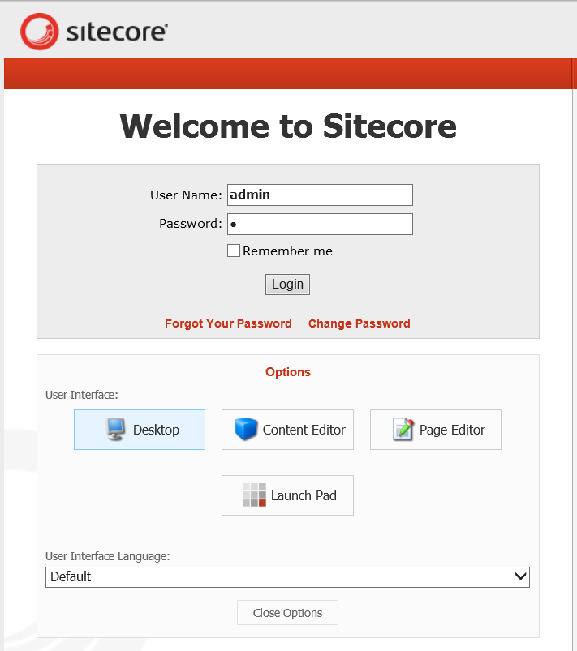
3. Open the Installation Wizard:  
   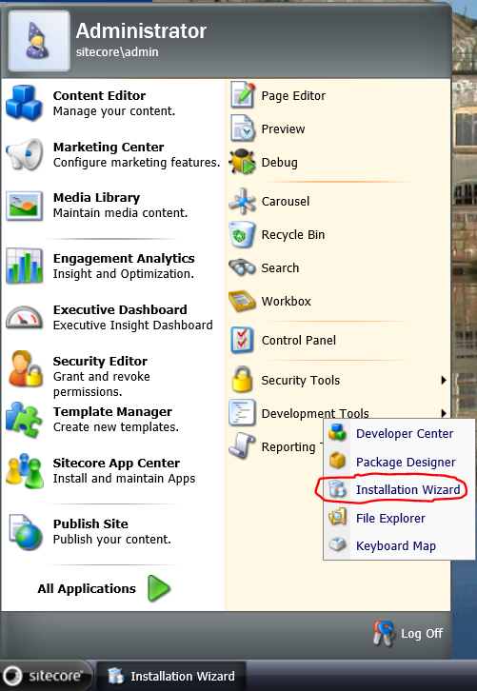
4. Upload the package and install it (if you get any messages about conflicts, choose “Merge” and then “Merge” again):  
   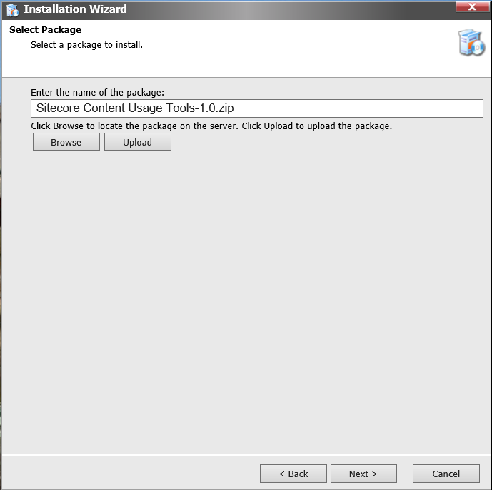
5. The server may experience a short interruption. You only need to install the module on you content management server.
6. You’re all set to start using the Sitecore Content Usage Tools!

# Finding unused content in the content tree

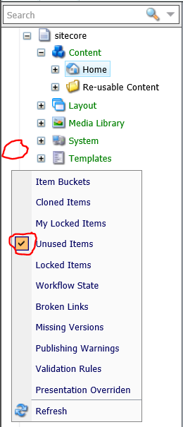When you open the content editor, you’ll notice an empty bar next to the tree of items. If you right-click it, you’ll see a menu that allows you to choose different items. Ensure that “Unused items” is checked.

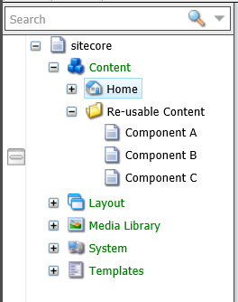Now, as you navigate through the content tree, below the */sitecore/content* and */sitecore/media library* nodes, you’ll see that some items will have a marking.

This means that the content item is not being referenced from any page.

If you’re certain that this item can be removed, simply click the item and you’ll be asked to confirm deletion of the item.

# See what pages use a particular piece of content from the content editor

When your are editing content items that can be used as associated content for components on the pages, you may want to know on what pages that content is being used. For this purpose, you’ll see a message at the top of the page when you open the “Content” tab.

The message only shows up when it is relevant (for items that are not pages and are within the content or media subtrees). It will show either a message listing the pages where the content is used, allowing you to navigate to those pages by clicking them...

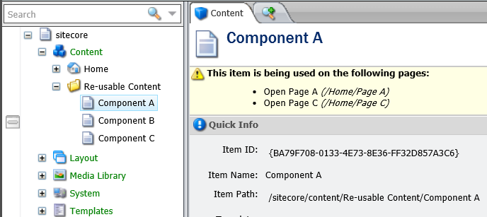

...or it will show a message saying that no pages use that particular item. In that case, a link will be displayed allowing you to delete the item (after a confirmation).

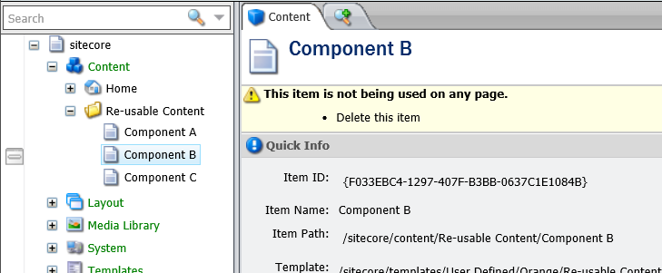

# See what other pages content is being used on from the page editor

If you open a page in the page editor, and you select a component on the page that has associated content, a pane will be displayed on the bottom right corner of your browser window.

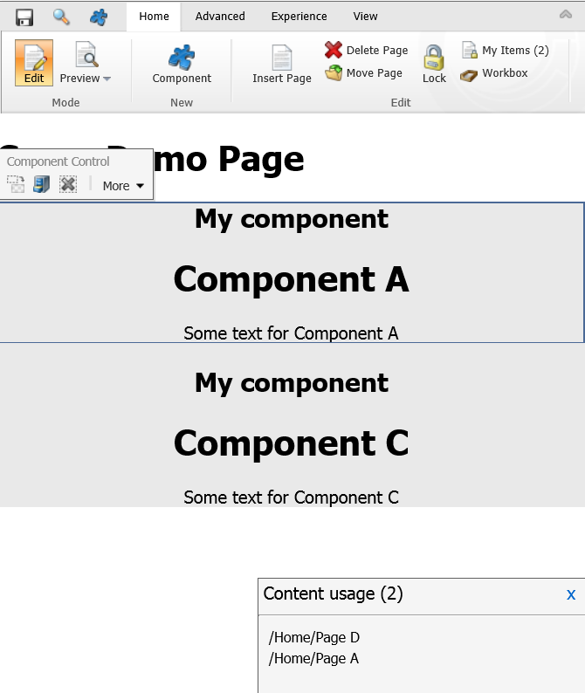

In this case, we are looking at “Page C”. And “Component A”, that is selected in the page editor is displayed to have associated content that is used in pages D and A as well. So if you’re going to do inline editing on this component, you should realize that pages D and A will also be affected.

In case you decide that you don’t want the other pages to be affected, you can choose to clone the current content by selecting “Clone Current Content” in the “Select associated content” popup. This is a function that is available in Sitecore by default (it is outside of the scope of this document).

For your convenience, the number of pages that also use the selected content is displayed in the “Content usage” pane.

If there are no other pages that are using this content, the following will be displayed. In this case it is safe to edit the content, because other pages won’t be affected.

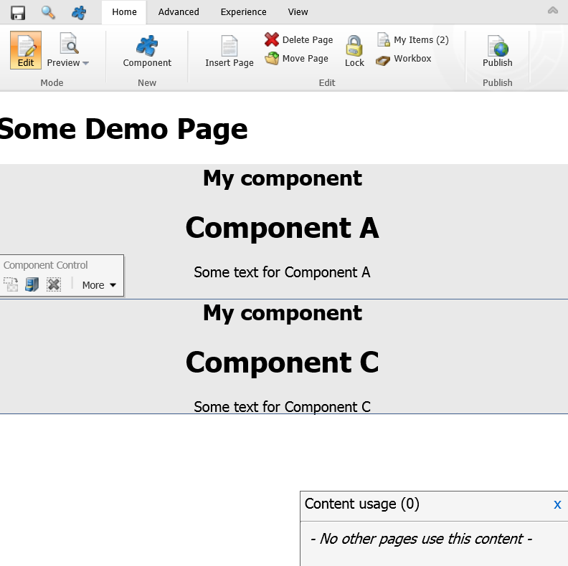

# Using reports to get an overview of where content is being used or obsolete

Please open the Sitecore desktop and navigate to the “Content Usage Report” application.

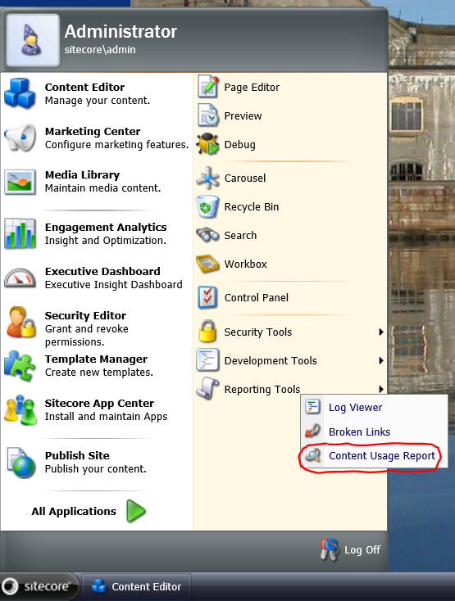

The following window will open:

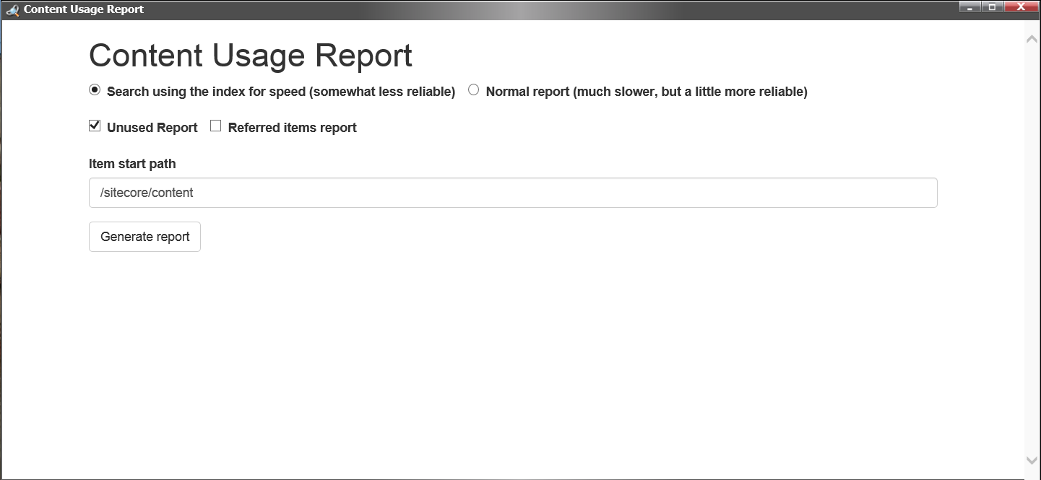

This form allows you to generate a report in one of 2 ways:

1. **Using the Sitecore content search index** – this is by far the fastest way of generating a report, but it has the drawback of being unreliable if the index is not up to date. We recommend rebuilding the search index before the first use, because additional data needs to be indexed (use the indexing manager from the control panel to rebuild the index).
2. **Using the normal report** – this is much slower, and we recommend you to not use it if you have a very large amount of items in your database. The results are more reliable though.

Then there are 2 reports that you can generate (at the same time, if you like):

1. **Unused report** – this generates an overview of items that are not currently being used on pages.
2. **Referred items report** – this generates an overview of all the content items (that are not pages) and it shows all the pages that they are being used on.

Finally, there is a way of limiting the scope of the report by setting a specific path within Sitecore. The report will cover only items that are descendents of the item path that is given. The value is */sitecore/content* by default, covering everything in the content part of the tree.

To start generating the report, press “Generate report”. The result might be something like this:

